- Purpose
  - The purpose of this document is to describe the procedure for assembling the base on an orbital machine.
- Scope
  - This SOP applies to all equipment assembly team members. The process applies to the following machine ID’s:
E12801EQM0600BA1000 – Basic Sand Dragon, 20”
E012801EQM0607BE1200 – Crewman ORB 20
E012801EQM0607BA1200 – Basic Sand Dragon 20, Canadian
E012801EQM0607BE1200 – Crewman ORB 20, Canadian
E012806EQM0600BA1000 – Basic Sand Dragon, 20”, w/ Weights
E012806EQM0600BE1200 – Crewman ORB 20, w/Weights
E012806EQM0607BA1200 – Basic Sand Dragon 20, w/Weights, Canadian
E012806EQM0600BE1200 – Crewman ORB 20, w/Weights, Canadian
E012811EQM0600BA1000 – Basic Sand Dragon, 28”, w/Weights
E012811EQM0600BE1000 – Crewman 28 ORB, w/Weights
E012811EQM0607BA1200 – Basic Sand Dragon 28, w/Weights, Canadian
E012811EQM0607BE1200 – Crewman ORB 28, w/Weights Canadian

- Responsibilities
  - The operations manager/supervisor is responsible for enforcing this SOP.
- Materials
  - The proper materials needed for this process are listed on the machine work order.
  - Hand/Power Tools
- Definitions

- Procedure
  - The process starts with a cast base (89611 for a 20” machine or 89652 for a 28” machine). Place the base upside down on a table.
  - Clear the axle holes of any paint. Take a handle support axle (89677) and place it through the hole on the base as shown. On the inside of the support place a nylon washer (83145) over the axle.
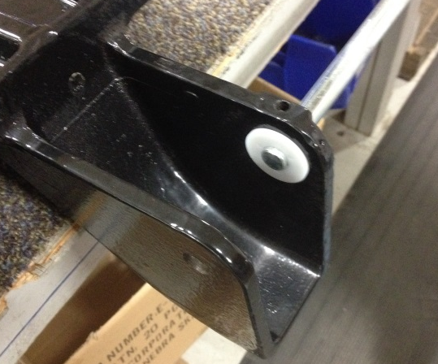
  - Place a wheel (12689) inside of the support and start to feed the axle through it.

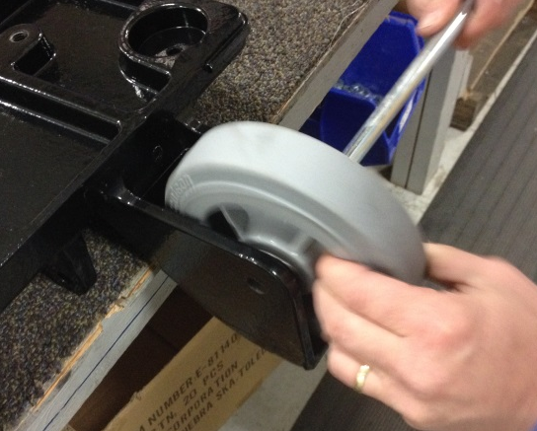

  - Place another nylon washer (83145) between the wheel and the support. This can be tricky. Once that is done, feed the axle through the 2nd support wall, but no further. This will hold the 1st wheel in place.

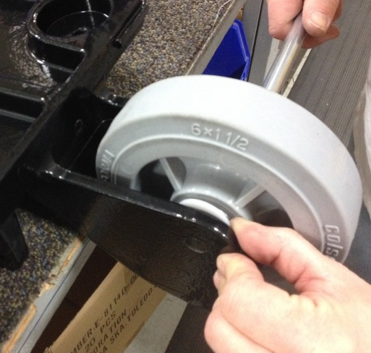

  - Take a handle support weldment (89659) and place a step bushing (89669) into each end of the tube as shown.

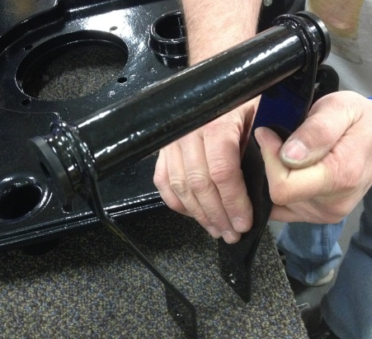

  - Place the weldment between the two wheel supports on the base as shown. Push the axle through it until it starts to go into the 2nd wheel support.

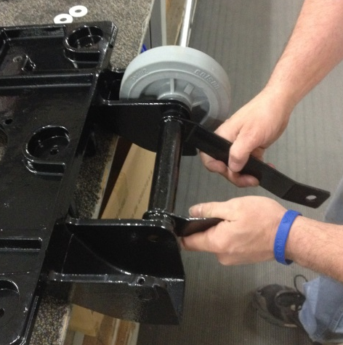

  - Install another wheel (12689) with a nylon washer (83145) on each side into the 2nd wheel support. Push the axle through this so that the entire assembly holds together. Center the axle.

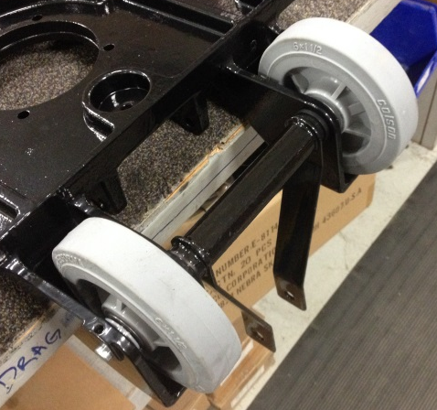

  - Secure the axle by installing a snap ring (89711) onto each end of the shaft.

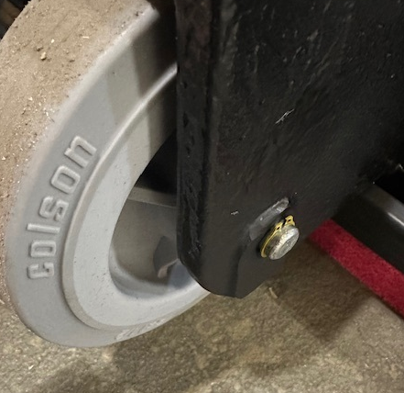
  - Place a bumper around the outer edge of the base. Use 89613 for a 20” machine or 89674 for a 28” machine. The bumper may be difficult to stretch around the edge. A pry bar may be needed to assist. Position the seam in the bumper between the rear wheels.

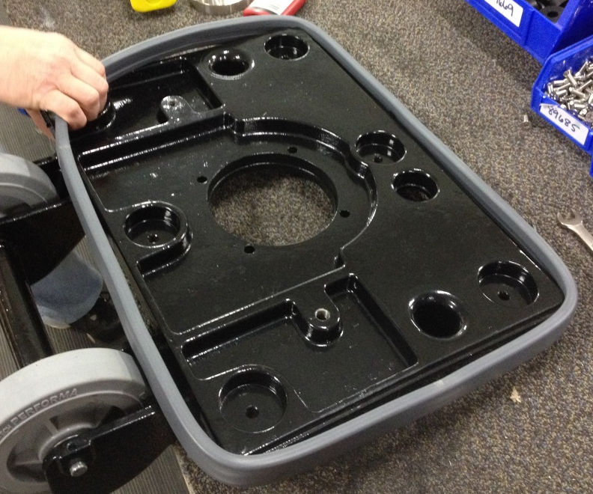
Seam

  - Base assembly is now complete.

- References (optional section as needed)

- Training Guide

Functional Training Groups Requiring Training
Equipment Assembly Group

- SOP Change Control

Date of Change | Reason for Change
Rev 01 - 4/28/2015 | This is the first version of the S.O.P. hence there are no revisions to this document.
Rev 02 - 1/16/2018 | Added the Responsibilities Section
Rev 03 - 3/6/2025 | Removed work center notes and updated snap ring notes
Approvals

Submitter/Author Approval:__________________________________ Date:______________________

Management Approval:______________________________________ Date:______________________

QAU Approval:_____________________________________________ Date:______________________

